V-Electronics: Revolutionizing Smart Device Management

**Phase 7: Integration & External Access**

Modern businesses often require data exchange with third-party systems. For V-Electronics, Salesforce needed to integrate with **ERP systems, Payment Gateways, and Supplier Databases**. This phase focused on secure, scalable integrations.

**1. Introduction**

Integration expands Salesforce’s capabilities, enabling real-time synchronization of data across systems. Salesforce offers **APIs, Platform Events, and External Objects** for smooth communication.

**2. Objectives**

* To enable external systems to securely interact with Salesforce.
* To configure authentication and authorization for APIs.
* To implement event-driven data sharing.

**3. Detailed Description of Contents**

**Named Credentials**

* Configured **Named Credentials** for secure authentication to ERP APIs.

**External Services & Salesforce Connect**

* Connected with supplier systems via **Salesforce Connect** to fetch live product availability.
* Used **External Services** to integrate payment gateway APIs.

**Web Services (REST/SOAP)**

* Built RESTful services to allow external apps to push/pull customer order data.
* Example: Payment confirmation pushed from gateway to Salesforce.

**Callouts**

* Implemented HTTP callouts to fetch delivery status from logistics APIs.

**Platform Events & Change Data Capture (CDC)**

* Used **Platform Events** for order status notifications.
* Used **CDC** to notify external systems about inventory updates.

**API Limits**

* Designed integration strategy within Salesforce API limits to prevent throttling.

**OAuth & Authentication**

* Configured **OAuth 2.0** for secure logins for third-party apps.

**Remote Site Settings**

* Configured external domains for callouts.

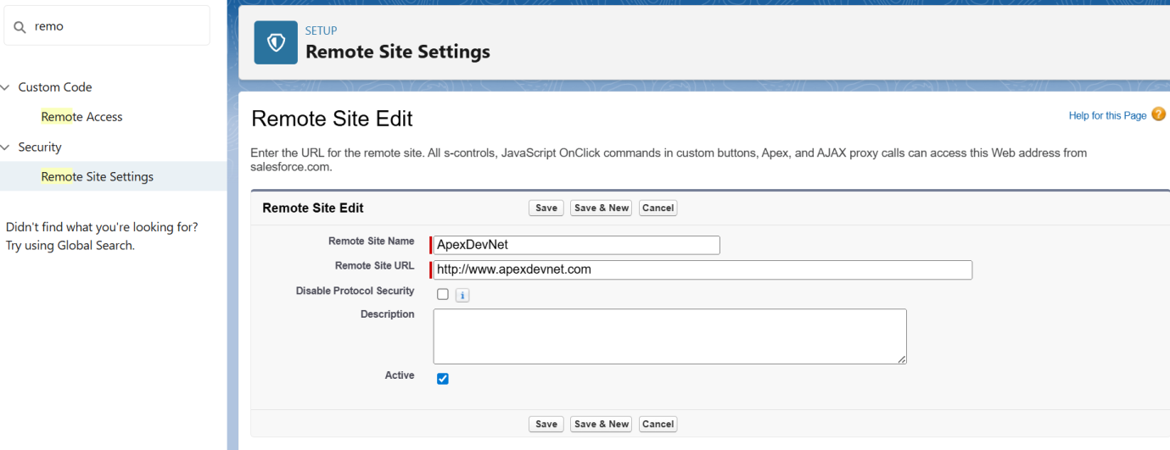

**4. Deliverables**

* Seamless integration with ERP, Payment, and Logistics systems.
* Platform Events and CDC for real-time data sync.
* Secure authentication using OAuth and Named Credentials.

**5. Conclusion**

This phase ensured Salesforce acted as a **central hub**, exchanging data with all business-critical systems in a secure and efficient way.